The itinerary presented here takes place from 9:00AM to 9:00PM. This is a total of 12 hours. I have chosen 6 locations to visit during this time. First, we will visit the Indianapolis Canal and explore the area for around an hour and 45 minutes. This is the first location that opens, and the early morning walk will prevent it from being too hot. Next, we will visit the Indianapolis Museum of Art. With a 4.5-star rating, it is a must-see and offers something for everyone. The recommended duration of the visit is 2 hours, this will give everyone a chance to explore and eat lunch while we are here. Accommodations are available for those who need them upon prior request or at the front desk. Next, we will visit the Garfield Park Conservatory & Sunken Garden. There is a cost of $3 per person. It has a travel time of about 21 minutes, which will give everyone a chance to sit and rest their feet for a bit before the next walking-based activity. The Conservatory is a beautiful rainforest-plant-filled garden with occasional art installations. It is also rated at 4.5 stars and is a must-see. After 2 hours, we will head to the Circle Center Mall. Here, people can choose to shop, see a movie, eat dinner, play arcade games, and more. This will also allow for those who need a break to sit down and rest, as it is a long day that not everyone can keep up with equally. To finish the day, we will head the 2 minutes over to Monument Circle so everyone can observe this Indiana Landmark. At night, it is lit up with string lights and a blue glow. There are plenty of shops around this area that can be explored as well, and pastry restaurants I highly recommend.

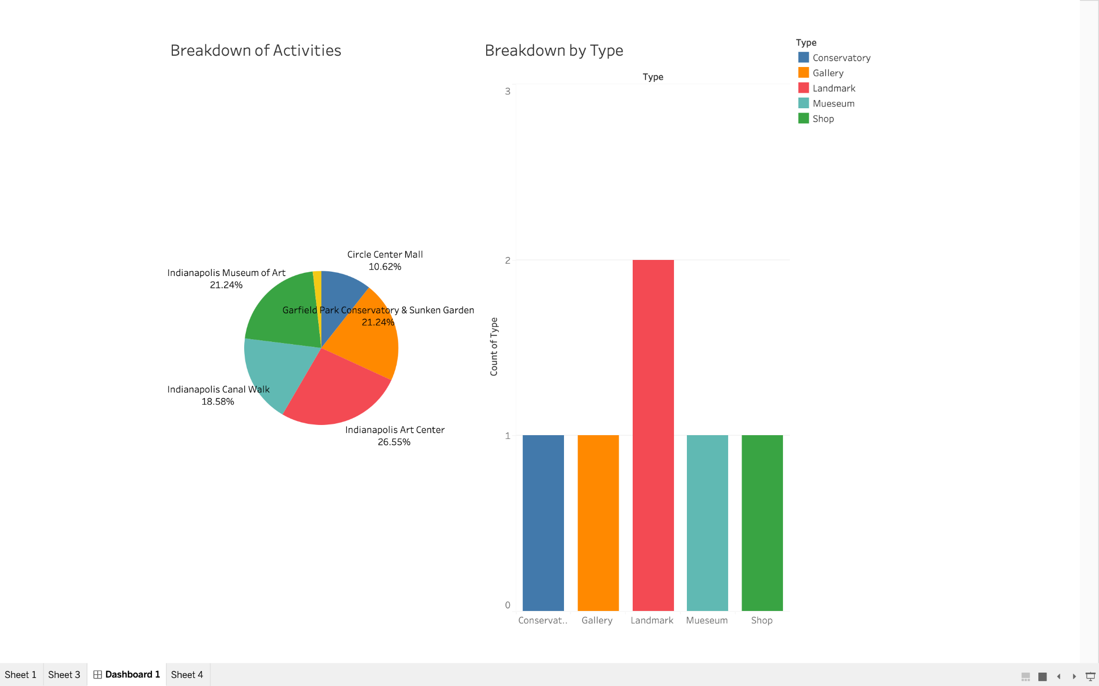

Figure 1

Figure 1 shows a breakdown of activities. The chart shows the percent of the total 12 hours that each activity takes up. The second chart shows a breakdown by activity type, with Landmarks having 2 activities and the other categories having 1 each. This was created using Tableau.